Lab No:

0
1

✵ Lab Title: Installation of C++ and Running First Program

o Learning objectives:
- The objective of this lab is:
- To make a group of three students
- To install C++ compiler and Visual Studio Code
- To configure C++ in Visual Studio Code
- To run a simple C++ program
- To display the names of group members using C++

Software Requirements
The following software is required:
- Visual Studio Code
- C++ Compiler (MinGW / GCC) ➢ Windows Operating System.
- Theory:
1. C++ is a programming language used to develop software, applications, and systems.
Visual Studio Code (VS Code) is a code editor used to write and run C++ programs.
2.To run C++ in VS Code, we must install:
- VS Code editor
- C++ compiler
- Required extensions

- Procedure
- Step 1: Download Visual Studio Code
- Open browser
- Go to official website: https://code.visualstudio.com
- Click Download
- Install VS Code
- Purpose: Visual Studio Code is used to write and run C++ programs.

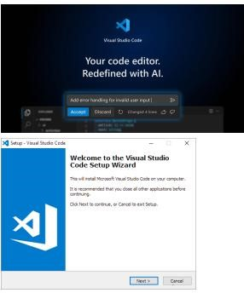

Step2:Installation of MinGW Compiler
steps:
- Opened website https://sourceforge.net/projects/mingw/
- Downloaded MinGW installer
- Installed MinGW software 4. Opened Installation Manager
- Selected package:

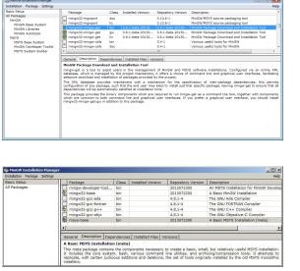

mingw32
-
gcc
-
g++

- Clicked Install → Apply Changes
Purpose: MinGW is used to compile C++ programs.

Step 3.Adding MinGW Path to Environment Variables
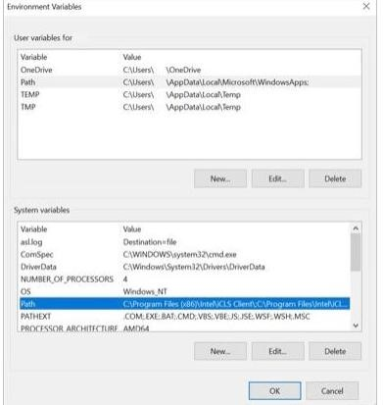

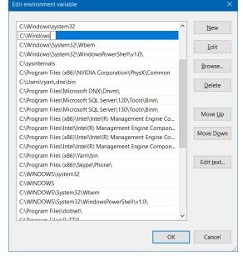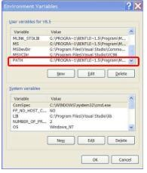

Steps:

Steps:
- Copied path: C:\MinGW\bin
- Opened Environment Variables
- Clicked Path → Edit
- Clicked New
- Added path
- Clicked OK
Purpose: This allows system to recognize the g++ compiler.

Step 4.installation of Extensions in Visual Studio Code

Extensions Installed:
- C/C++ Extension
- Code Runner Extension
Purpose: These extensions help in compiling and running C++ program.

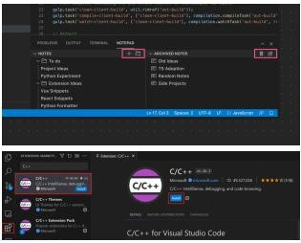

Lab tasks :perform one by one all tasks

Task 1: Make group of three students
Group Members: 1. Hidayat Ullah 2. Anis Ahmad 3. Jawad Ali

Task 2: Understand lab instructions
All instructions were read and understood.

Task 3: Complete installation and setup
Successfully installed:
- Visual Studio Code
- MinGW Compiler
- Environment Variables
- Extensions

  - Task No: 04
  - Write a simple C++program.

#include <iostream>
using namespace std;

int main()
{
cout << "Group Members:" << endl;

cout << "Hidayat Ullah" << endl;
cout << "Anis Ahmad" << endl;
cout << "Jawad Ali" << endl;

return 0;
}

Output:
Group Members:
Hidayat Ullah
Anis Ahmad Jawad Ali

- Conclusion of lab:
- In this lab, we learned:
- • Installation of Visual Studio Code
- • Installation of MinGW Compiler
- • Setting Environment Variables
- • Installing Extensions
- • Running C++ Program
- The C++ development environment is now ready for programming.

